COMMISSION REPORT FOR SALES PERSONNEL |

A Complete Excel-Based Business Analytics System

6.1 Project Overview
This project focuses on building a comprehensive commission and compensation management system for car dealership personnel using Microsoft Excel. The dataset includes dealer details, vehicle brands, sales performance, commission rates, and bonus eligibility.
The primary goal of this project is to simulate a real-world business scenario where a sales manager needs an automated Excel system that:
- Calculates commission and bonus
- Provides total compensation
- Summarizes high-level analytics
- Allows quick lookups
- Generates visual insights
- Gives clean and accurate business reporting
This project demonstrates how Excel can be effectively used as a financial computation tool, a data analysis platform, and a decision support system.

6.2 Data Entry and Table Setup
The first task was to set up the sheet by manually entering the dealer information. This included:
- Dealer ID
- Dealer Name
- Brand
- Location
- Total Sales
- Commission Rate
The entire range was then converted to an Excel Table using:
Insert → Table

This allowed:
- Automatic formula expansion
- Structured references such as [@SALES]
- Easy filtering and sorting
- Improved dataset readability
Excel Tables make the entire system dynamic — if new rows are added, all formulas automatically adjust without manual updating.

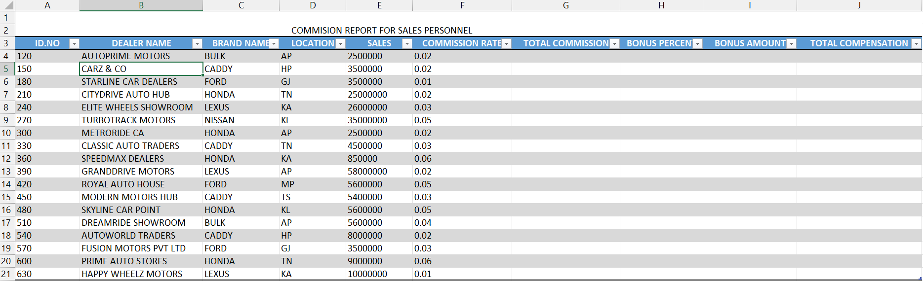
Screenshot of inserting table detail manually

6.3 Formatting and Layout Setup
To make the report professional:
- Column widths were adjusted
- Header fonts were bolded
- AutoFormat was applied for a clean corporate design
- Number formatting was used to show currency and percentages
- Extra spaces were removed using TRIM function
A well-formatted sheet improves clarity, reduces confusion, and makes the report visually presentable for business meetings.

6.4 Commission Calculation (Core Computation)
Commission is calculated using the formula:
Commission = Sales × Commission Rate
In the table, the structured reference formula is:
=[@SALES] * [@COMMISSION RATE]
This gives each dealer’s earnings purely based on their sales and commission percentage.

- Helps evaluate sales performance
- Useful for payroll distribution
- Allows comparison between dealers
- Forms the base for total compensation
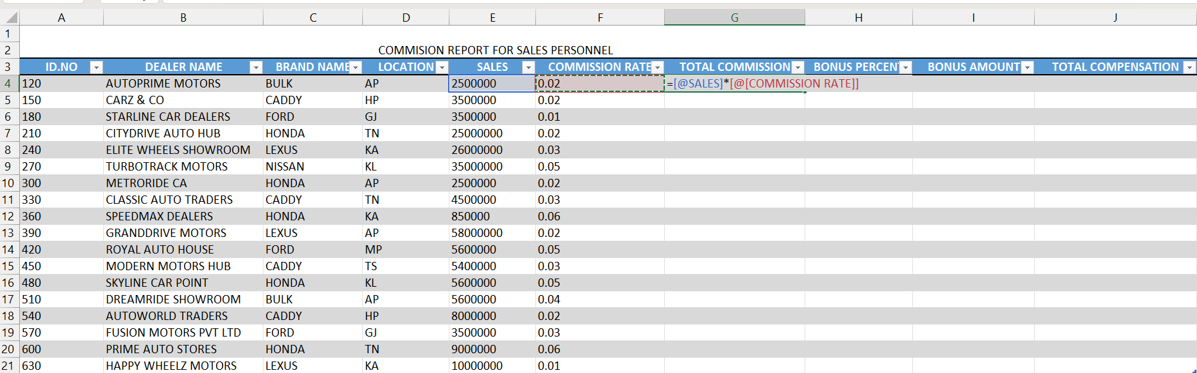

6.5 Bonus Calculation Using IF Function
A performance-based bonus was added to make the system more realistic.
Business rule:
- If Sales ≥ ₹5,00,000 → Bonus = 5% of Sales
- Else → Bonus = ₹0
Formula:
=IF([@SALES] >= 500000, [@SALES] * 0.05, 0)
Real-World Purpose:
- Incentivizes employees
- Rewards high-performers
- Helps management plan reward systems
- Improves motivation and sales growth

Screenshot of formula used to calculate bonus

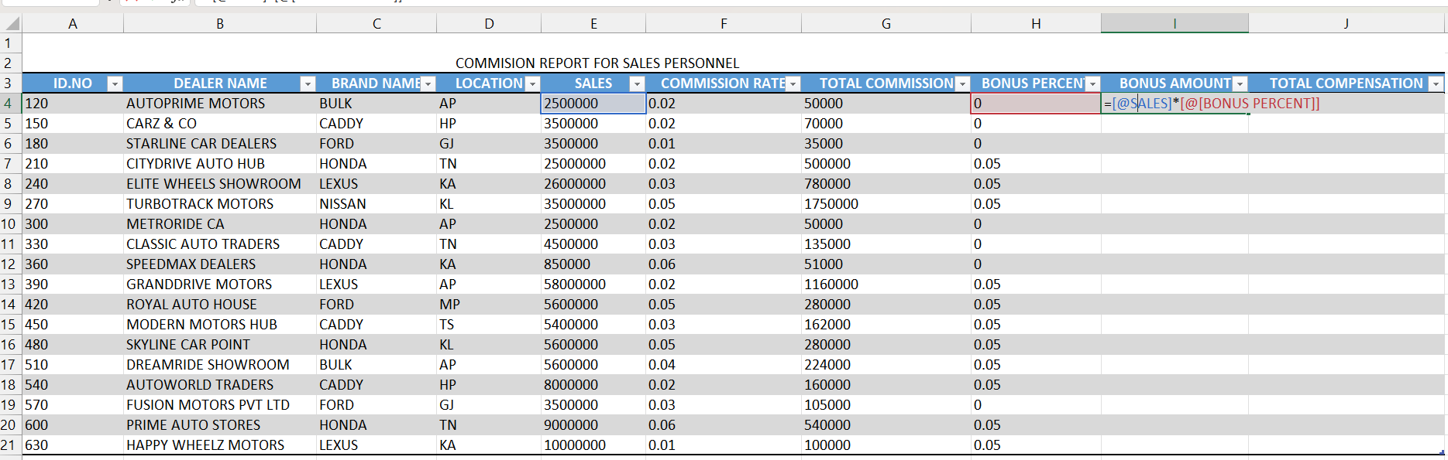
Screenshot of bonus amount calculation

6.6 Total Compensation Calculation
Total Compensation is:
Total Compensation = Commission + Bonus
Formula used:
=[@TOTAL COMMISSION] + [@BONUS AMOUNT]
This gives a complete earning summary for each salesperson.

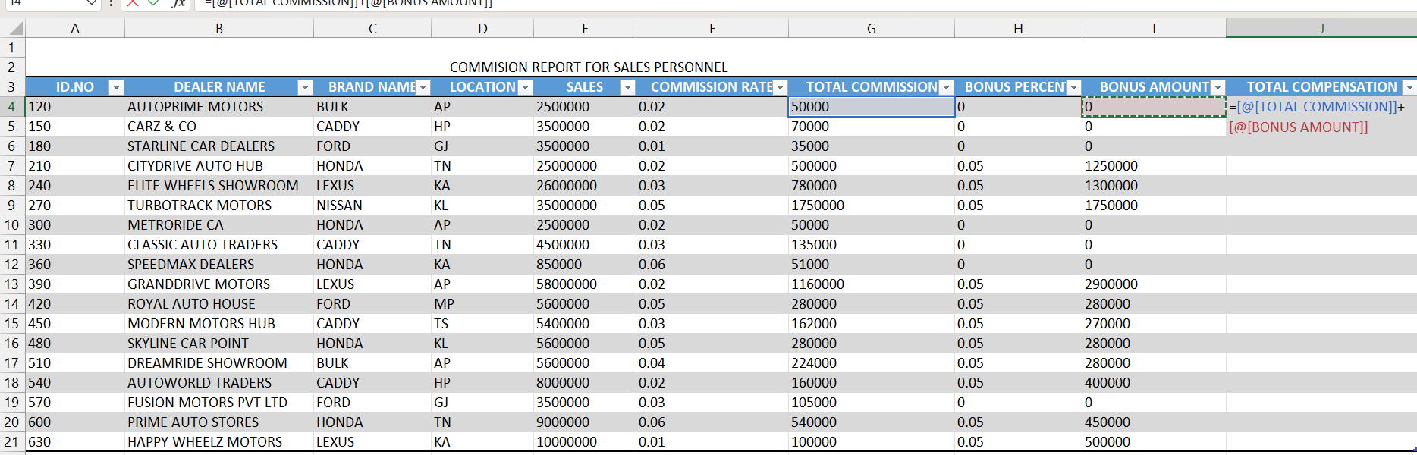

Screenshot of calculation formula used to find total compensation

6.7 Summary Metrics and Statistical Functions
To analyze the dataset, several Excel functions were used.
6.7.1 Highest Compensation
=MAX(I:I)
Identifies the best performing dealer.

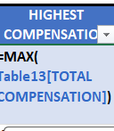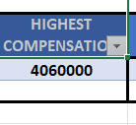
Screenshot of finding highest compensation

6.7.2 Lowest Compensation
=MIN(I:I)
Shows the lowest earning employee.

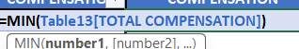

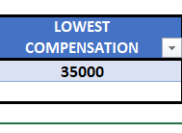
Screenshot of finding lowest compensation

6.7.3 COUNT
Counts numerical values like sales entries.
=COUNT(E:E)
4.7.4 COUNTA
Counts names and text values.
=COUNTA(B:B)

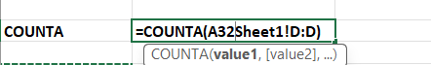
Screenshot of finding COUNTA

4.7.5 LEN
Used to check name length for data uniformity.
=LEN(B4)
6.7.6 TRIM
Removes unwanted spaces in names.
=TRIM(B4)

- Helps understand dataset quality
- Shows employee performance variation
- Supports business decisions with numerical analysis

6.8 Brand-wise Dealership Frequency Using COUNTIF
To count how many dealers belong to each brand:
Example:
=COUNTIF(C:C, "HONDA")
This helps the business understand:
- Brand presence
- Market reach
- Which brand contributes the most dealers
- Inventory planning needs

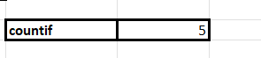
Screenshot of finding number of honda brand dealership

6.9 VLOOKUP for Quick Compensation Retrieval
VLOOKUP was used to instantly fetch compensation for a specific dealer.
Example:
=VLOOKUP("CARZ & CO", A:I, 9, FALSE)
Use Case:
- Instant retrieval during reviews
- Helps managers check any employee’s pay
- Supports salary verification
- Saves time compared to manual searching

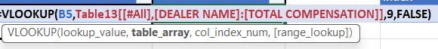
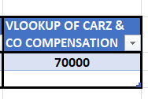
Screenshot of vlook of carz and co

6.10. SUMIF and SUMIFS (Conditional Summations)
SUMIF:
=SUMIF(C:C, "HONDA", G:G)

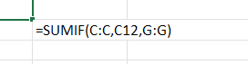

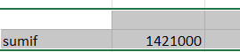
Screenshot finding SUMIF

SUMIFS:
=SUMIFS(G:G, C:C, "HONDA", D:D, "TN")

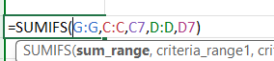

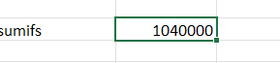
Screenshot of finding SUMIFS

Business Application:
- Identify brand performance
- Check region-wise commission totals
- Plan marketing budgets
- Analyze sales by segment

6.11 Use of Conditional Formatting Icons in Total Compensation Column
To make the compensation results visually meaningful, I applied Conditional Formatting Icon Sets to the Total Compensation column. This feature helps users instantly understand performance levels without reading individual numbers.
Purpose of Conditional Formatting Icons:
- Highlights high and low compensation values
- Makes the report visually attractive
- Helps managers quickly identify top and low performers
- Converts raw data into an easy-to-read visual signal
- Improves decision-making and analysis speed

I used the following Excel steps:
- Selected the Total Compensation column
- Went to Home → Conditional Formatting → Icon Sets
- Chose the Directional Arrows icon style
- Excel automatically assigned:
  - Green Up Arrow (⬆️) → High compensation
  - Yellow Side Arrow (↔️) → Average compensation
  - Red Down Arrow (⬇️) → Low compensation
These arrows are applied based on Excel’s default percentage-based rule:

Icon Meaning (What Each Arrow Represents)
🟢 Green Up Arrow – High Compensation
Indicates the top performers with the highest earnings.
These employees have:
- High sales volume
- Higher commission
- Higher bonus
- Strong contribution to revenue
This helps the company identify top-tier performers for rewards and recognition.

🟡 Yellow Right Arrow – Medium Compensation
Represents average performance.
These values fall in the mid-range of all total compensations.
Employees in this category:
- Are meeting expectations
- Are stable contributors
- Have potential to grow with targeted training

🔴 Red Down Arrow – Low Compensation
Shows employees with the lowest sales and earnings.
Typically indicates:
- Low sales figures
- Lower commission
- No or minimal bonus
- Possible need for training or review
This helps management easily focus on areas requiring improvement.

Why Conditional Formatting is Important in This Project
Adding icon sets to numerical columns is extremely useful because:
✔ Turns data into visual indicators
Instead of scanning large numbers, the eye instantly catches arrows.
✔ Helps in performance analysis
Managers immediately know who is performing well or poorly.
✔ Makes the report professional
This is a very common feature in business reports, sales dashboards, and financial statements.
✔ Enhances readability
Even non-technical people (HR, managers) can understand the report.
✔ Helps during presentations
Visual signals are more impactful during review meetings.

Final Benefits
Using Conditional Formatting:
- Improves data interpretation
- Enhances report quality
- Supports decision-making
- Adds visual intelligence to the Excel dashboard
This makes your project look advanced, well-structured, and corporate-standard.

6.12 Charts and Visual Analytics
To improve data understanding, several charts were created:
Funnel Chart
Shows compensation distribution across sales personnel.
Column Chart
Displays dealership count by brand.
Bar Chart
Compares highest vs lowest earners.
Table Chart
Shows all computed values clearly.
Purpose of Visualization:
- Converts numbers into insights
- Helps management view performance at a glance
- Easier decision-making
- Highlights trends and outliers

6.13 Insights from the Analysis
Based on the completed report, the following insights were observed:
- Dealers with higher sales consistently earn larger commissions.
- Bonus strongly increases total compensation for top performers.
- Some brands (like Honda) have more dealerships, reflecting stronger market presence.
- Compensation differences show clear sales performance variation.
- Locations like KA and TN show strong sales results.
- VLOOKUP helps accurately check dealer earnings without searching manually.
- SUMIF and SUMIFS help evaluate brand and location-based performance.

6.14 Final Conclusion
This project demonstrates how Microsoft Excel can be used to build a complete Compensation Management System that includes:
- Automated commission and bonus calculations
- Conditional logic with IF
- Advanced lookup systems with VLOOKUP
- Data cleaning with TRIM and LEN
- Statistical analysis using COUNT, SUMIF, etc.
- Visual insights through charts
- Brand and location performance analysis
This project showcases the power of Excel to perform real-world business analysis, and the final output resembles a professional corporate report that a sales manager would use for decision-making

6.15 screenshot of excel sheet
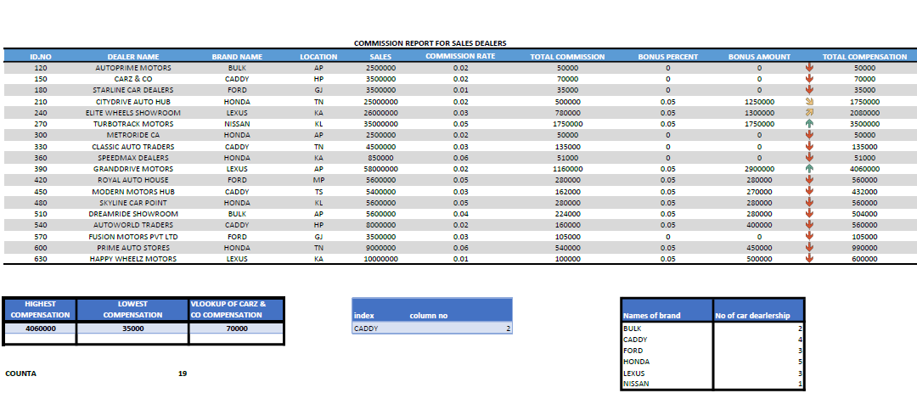

I have also used chart to represent dealers compensation
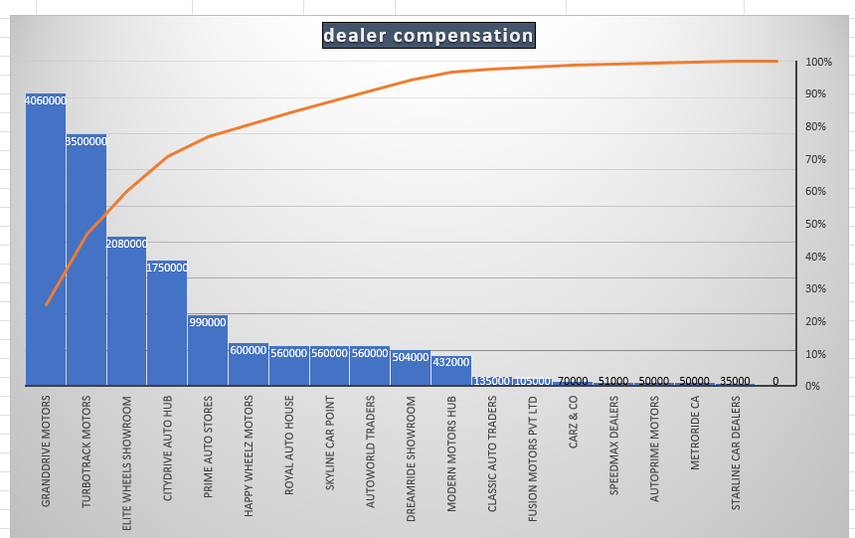

Screenshot of chart

